Rad Consult Room AV Guide

To Power the system ON

- On the wall panel, tap the Home icon
- Tap on System Power
  - All monitors and computers will power on
  - Wait 5-10 seconds

-----------------------------------------------------------------------------------------------

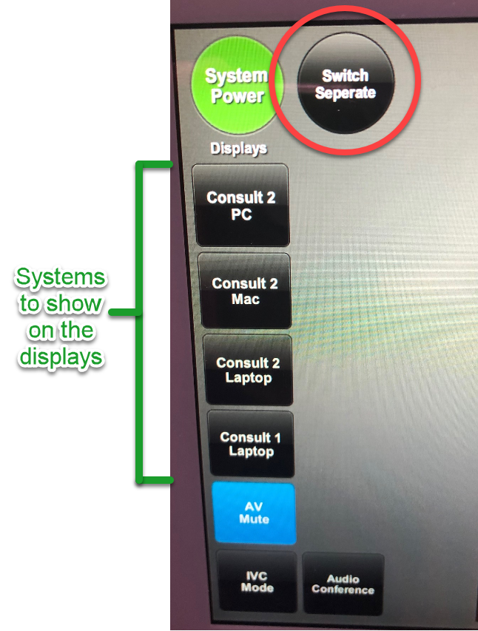
To set all displays to show the same source computer

- Tap Switch button until it goes dark
(see red circle)
- Tap on the system you want to display
  - Wait 5-10 seconds

If you want the screen to temporarily be black, tap
On AV Mute.

-----------------------------------------------------------------------------------------------
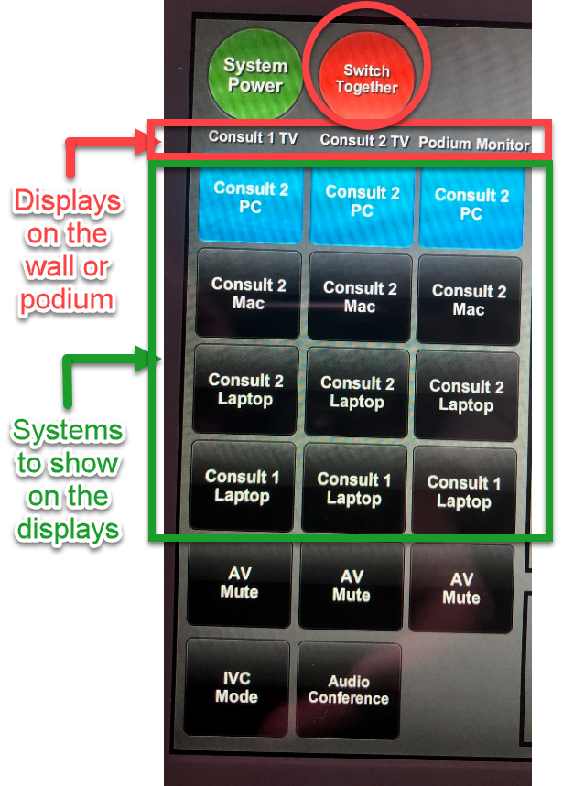
To set different source computers to different displays

- Tap Swich button until it lights up red
(see red circle)
- Tap on the system corresponding to the display
  - Wait 5-10 seconds

If you want any screen to temporarily be black, tap
On AV Mute.

Consult 1 TV is the monitor on the left

Consult 2 TV is the monitor on the right

Consult 1 laptop is the wall port under the left wall monitor

Consult 2 laptop is the cable connection in the
podium

Note that the keyboard and mouse always point to
the computer that displays on the Podium Monitor

-----------------------------------------------------------------------------------------------

To Raise/Lower the divider wall

NOTE: Two people are required

- Move all furniture and obstructions away from where the wall is or will be!
- Turn the key to the Up or Down arrow side
  - If the key is missing, check Rad Admin offices
  - It’s not necessary to hold the key in position
- Press and hold both silver buttons (one in each room) until the wall is fully deployed/retracted
  - Move takes 3-4 minutes
- Return key to center position

